OBE File Import / Exporter for Max 2.5
Version 0.04b

User Documentation

Introduction
What is it
Machine Specifications
Undocumented Features
Reporting Bugs or errant program crashes
Using the plugin
Installation
Importing a file
Importer Options
Adding Texture Paths
Wish List
Revision History
Version 0.04b
Version 0.03b
Version 0.02b
Version 0.01b

Introduction

What is it

The OBE file importer/exporter allows you to import OBE file into 3D Studio Max with all animation, texture information and gouraud values intact, and also allows you to export meshes from 3DS Max to Jobe with animation, textures and gouraud information.

Machine Specifications

If you can run 3DS Max 2.5, then you can definitely run the plugin with no real problems. However if you intend to have textures displaying in viewports, it is recommended that you have at least 128Mb 64Mb of RAM without no other applications running in the background.

Undocumented Features

Despite the fact that I have tried to make the plugin as bug free as possible, there are bound to be one or two things that were un-fixable before the deadline crept up and well and truly shafted me when I wasn’t looking. This is a “known-bugs” list, which is stuff I fully intend to fix in the near future, but hopefully will not make life a complete tragedy for those of you using the plugin. Needless to say, that I am woefully ashamed to release software with any bugs at all…..

- Either on some or all quads, the texture appear to be upside down. This has something to do with Jobe’s planar mapping, and not the way in which I’m splitting quads into triangles, as I first thought.

- The importer and exporter, both use huge amounts of memory and don’t bother to free the memory when done. This is because the copy of the plug-in that you have in your greasy little mitts, is a debug build, which seems to crash when I free up memory that I’ve been using. I would let you use the release-build but it crashes just as badly.

Reporting Bugs or errant program crashes

Please don’t all rush down to me here in my pit, screaming that it won’t work. I understand how frustrating it can be to have a tool that will be well used to suddenly crash.

Until then, please e-mail me, about the bug/crash (mark it as Urgent too) and make sure the e-mail has the subject of “OBE File Bug” and contains the following information ;

- A shortcut to the file you were importing/exporting when the bug or crash occurred ( be it Max or OBE).
- A description of the bug (if applicable)
- How urgent the bug fix will be (1 = If it’s not fixed by today, then you’re screwed; 2 = two to three days is okay)

Please keep in mind though, it might not always be the plug-in that crashes your computer. It’s not as if Max is the most stable of applications, or Windows 95 is the greatest operating system in the known Universe.

Using the plugin

Installation

It couldn’t be easier to install the plugin.

- Make sure that Max is closed.
- Copy the file “obefile.dlu” to the plugins fold in 3DSXMAX2.5 or where ever you have installed your copy of Max.
- Restart Max

And lo-and-behold, you’re plugin will be installed.

Importing a file

Importing an OBE file couldn’t be easier. Just follow the artist-proof steps below to instant karma and a non-chemically induced high.

- From the File menu select Import
- Now you’ll see a file select dialog. From here, click on the file-type select box and select “ISL Jobe (*.OBE)” as the file type to import.
- Click on OK and you will be confronted with yet another dilaog Box, bursting with options and things to play with.

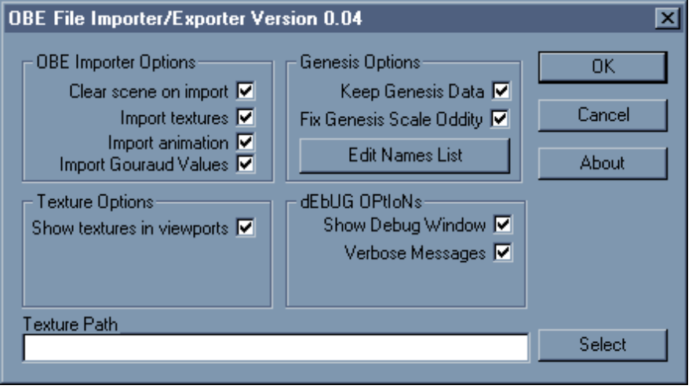
The OBE Import Options Dialog Box

- All of the options will be explained a little further on. Next, either type in the texture path, in the Texture Path box, or click on the Select button to bring up the Texture Paths list box.

- If you clicked on the Select button, the Dialog below will be showing.

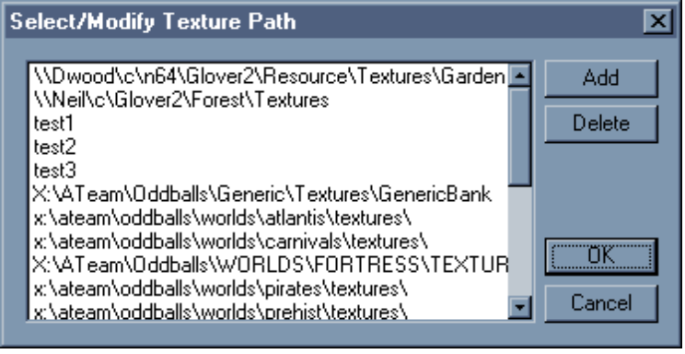
The Select/Modify Texture Path Dialog Box

- Select one of the texture paths available, or click on the Add button to add a new texture path to the list. The press OK to use the selected texture path, and it will be shown in the Texture Path text box.

- Click on OK to start importing the file, and hey presto ! It couldn’t be easier.

Importer Options

This a quick explanation of the various options in the Importer Dialog box.

Clear scene on import This will automatically clear the scene, when you import an OBE file.
Import textures Hmmmm…I wonder what on earth this does ?
Import animation I forget what this does…..
Import gouraud values Well blow me down !! I have absolutely no idea as to what this is for.

Keep Genesis Data This will load any extra data (not just Genesis) attached to meshes.
Fix Genesis Scale Oddity Fixes the scale problem with Genesis generated boxes (Box01 and
puzzle).

Show textures in viewports Yes ! you can finally view the textured models without rendering, Just
make sure this option is selected.

Show Debug Window Shows the debug window during the file import.
Verbose Messages Tells you in more detail what’s happening while importing the file.

Adding Texture Paths

The OBE plugin retains all the texture paths that you use, so that when you import a file, you do not have constantly type for browse for the texture paths. The plugin can store up to 65, 535 texture paths at any time. But I wouldn’t recommend using that many though……..

To add a texture path to the list, just follow the Hasbro-producer-proof steps below……

- While in the Modify/Select Texture Path dialog box click on the Add button.

- The Add Texture Path dialog box will now appear (see below)
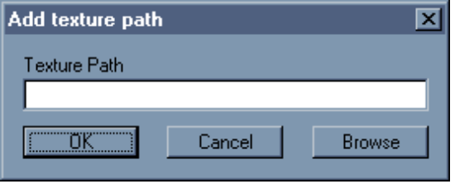
The Add Texture Path dialog box

- Either type in the texture path or click the Browse button to look for the texture path

- Click on the OK button and the texture path will be added.

Wish List

- This is my wish list. A list of stuff that I want to add to the plugin in the near future. If you can think of any suggestions (sensible ones please, and none involving animals…..) then please, by all means e-mail me.

- I want a compiler that works dammit !! But I don’t believe in miracles.

- The obvious one that occurred to me this morning while brushing my teeth, was to let the user to be able to select if they want to reverse the UV coordinates on quads. In case the upside down texture bug gets really annoying.

- For now, only the Debug version of the plugin works. I really want to get the Release build working,.

- I want a big red fire engine for Christmas broom broom !! Mee maw me maw, woooooooooooo…….

- A debug window, so if it does crash, then it’ll make it easier to spot what’s happening without having a copy of Developer Studio.

- Support for Genesis oddity’s. Things like actually saving Genesis data, fixing rotation and scale problems on instances of objects etc.

- The merging of coplanar triangles into the appropriate quads. For now, you’ll just have to manually do this in Jobe, with it’s merge poly’s option.

Revision History

Version 0.04b

- The importer can now display the textures in viewports
- Added an extremely dodgy fix, to retain texture tiling values across polygons.
- Took out the flip UV on Quads option. It didn’t work.

Version 0.03b

- Added option to import textures on quads, by flipping them upside down. This option is also available on the exporter.
- Added a Debug window to make fixing bugs easier.
- Fixed animation problem where, when animation is turned off, the position an rotation of meshes was incorrect. This is because Max, uses the key frame at time zero for the objects initial transform.

Version 0.02b

- Fixed bug where all polygons were set to transparent.
- Exporter now exports gouraud shading information, and default the polygon shading mode to pre-lit.

Version 0.01b

- First release.

